**Chandraleka (Chandralekha Prabhudas Patel) (b. 6 December, 1928, Wada, Gujarat, India – d. 30 December, 2006, Chennai, Tamil Nadu, India)**

**Summary**

Chandralekha Prabhudas Patel, known by the mononym Chandralekha, was a pioneering choreographer, dancer, writer, graphic designer, and social activist based in Chennai, India. Best known as a dance innovator, she originated an open-ended, layered movement style that has been variously labeled ‘modern’, ‘postmodern’, ‘avant-garde’, ‘Western-influenced’ and ‘experimental’ — although she resolutely rejected all of these categorizations. Initially trained in the classical dance Bharatanatyam, Chandralekha rebelled against the strictures of Indian concert performance by fusing the traditional lexicon with the structures and vocabulary of yoga, quotidian gestures, and Kalarippayattu – a South Indian martial art – to create a novel dance language devoted to the exploration of body politics in a contemporary frame. In the arc of her artistic career, which spanned half a century from the1950s to 2006, the period between 1985-1995 is often cited as the time when she crystallized her choreographic technique and vision. Regarded as an iconoclast, Chandralekha is also considered a controversial figure in the field of Indian performance for her radical approach to both art and politics, which she saw as indivisible from each other. She pursued her creative commitments up to the time of her death from cervical cancer in 2006. A significant force in the history of Indian dance, Chandralekha continues to serve as an influential figure for many artists working at the intersection of a number of indigenous and transnational South Asian forms.

**Training**

Chandralekha was born in Wada, Gujarat, to a wealthy family from Nadiad district. Her parents shaped her thinking in complementary ways: while her father, a doctor, was a self-described atheist, her mother managed the family household and was deeply religious. Chandralekha was exposed to a variety of cultural influences from childhood, as the family lived in Saurashastra, Gujarat; Pune, Maharashtra; and briefly, in Aden (now part of the Yemen Arab Republic). She began studying law in Bombay (now Mumbai), but left college and at age seventeen went to live in the city of Madras (now Chennai). There she was inspired by the art and culture she witnessed in her surrounds, and decided to devote herself to dance.

Under the tutelage of esteemed *nattuvanur* (dance mentor/choreographer) Guru Kancheepuram Ellappa Pillai, Chandralekha started to seriously study *dasi attam* (the dance of the devadasis) and Bharatanatyam in the early 1950s. In developing her style, she was also influenced by the early architects of the Bharatanatyam revival – Rukmini Devi Arundale, founder of Kalakshetra, the renowned arts institute; and T. Balasaraswati, a performer from the devadasi community.

**Contributions to the Field and to Modernism**

Chandralekha quickly achieved acclaim and became a dance luminary of her time. She was part of the first India cultural delegation sent to the USSR and China in 1952-1954. She choreographed the original piece, *Devadasi,* in 1961. Her image adorned the cover of the 2 June, 1963 issue of the popular magazine *Illustrated Weekly of India,* when she was the height of her fame as a soloist. Her exit from the stage was as dramatic as her meteoric rise: there existed, she felt, a wide chasm between the format and content of classical dance and the political exigencies that confronted society at large. This uneasiness had shadowed her since her 1951 *arangetram* (debut evening-length Bharatanatyam performance), which took place at a charity event in Chennai commemorating victims of a drought. Ironically, she had presented a piece called *Mathura Nagarilo* in tribute to the Yamuna river, which led to this feeling of dissonance. An amplified sense of disenchantment provoked her to abandon the performance circuit in the early 1960s. *Navagraha* (1972), a joint project with the dancer Kamadev, was her only other foray into dance in this period.

Chandralekha then turned her attention to other political commitments by working in graphic design, participating in feminist work, and writing poetry. She agitated with other activists against the Emergency (1975-1977) imposed by then-Prime Minister Indira Gandhi. For this she was charged with, and then cleared of, ‘acts of sedition’ by the central government in 1982.

After a hiatus of over a decade, Chandralekha returned to dance in January 1984, when she was invited to present her work in Bombay at the East-West Encounter co-organized by George Lechner, then-director of the Max Mueller Bhavan, and the National Centre for the Performing Arts. Rukmini Devi agreed to let Chandralekha work with four Kalakshetra dancers for this presentation, which included a *tillana* (pure dance item) reconstructed from *Devadasi*; Surya Namaskar, an excerpt from *Navagraha*, performed as a solo by the choreographer; and a new piece called *Lingashtakam*, a duet created in collaboration again with Kamadev. With her return to the dance world, Chandralekhadistilled her own movement idiom and inaugurated a fresh artistic approach, making corporeality itself the site of her first choreographic investigation. Her new oeuvre began with *Angika* (1985), a Sanskrit term for the body, and ended with *Sharira* (2001)— a different word with the same meaning.

Viewing classicized concert dance as an anachronistic commercial enterprise, too closely tied to representing the mystical and the mythological, Chandralekha sought to synthesize the theories and insights from a range of physical disciplines that could support her effort to comprehend the body in its relationship to space and time. The body, as she saw it, was not only a passive site for the inscription of heritage, but a dynamic entity, animated by great transformative potential.

**Legacy**

Chandralekha’s work is marked by the deconstruction of canonical forms and excavations of philosophies of gender and sexuality, temporality and tradition, the spiritual and the secular, energy and spirit. Committed to progressive social and aesthetic movements, her concerns with the individual body and the body politic were manifest in choreographies like *Sri* (1991), *Yantra—Dance Diagrams* (1994) and *Raga: In Search of Femininity* (1991). Devoid of spectacle, her minimalist dances nevertheless deployed a distinctive vocabulary that produced compelling visual, aural, and kinesthetic effects. In her work she centered control over the spine as the locus of power, or ‘the backbone of freedom’ (1997). In a sense she fully mined the *nritta* repertoire, or the abstract, pure dance possibilities embedded in Bharatanatyam, well represented in its cultural lineages and allied movement forms. From yoga and *kalaripayyatu*, she integrated perspectives on time, flow, and heightened physical self-awareness. Long before the concepts became formal theoretical categories in the academy and international art world, she practiced interdisciplinarity, intraculturalism, and hybridity. She saw the potential of recasting and reinterpreting tradition—effectively undoing the binary that separated it from the milieu of modernity.

The frank sexuality of Chandralekha’s work created controversy by disrupting audience expectations about the purpose of dance in the classical Indian context. Until she arrived on the scene, mainstream dancers tended to downplay the fact of the dancer’s public physicality, camouflaging the potential of her sexual presence in rhetoric about the sublimation of eros in *bhakti*, or devotional ambience. They thus framed dance as an explicitly ethereal, rather than corporeal, art. Chandralekha, in contrast, dealt directly with the erotic assemblage—as theme, as choreographic principle, as movement motif, exploring the haptic, the tactile, and the sensual interstices between bodies without reservation. The central Indian government took an ambiguous stance on her work for these reasons, at first rejecting its value and then recognizing her power as an artist. In 1987, Chandralekha served as chief choreographer for the opening program at the USSR’s Festival of India, with then-Premier Mikhail Gorbachev among the notable attendees. The dance *Namaskar* had been specially commissioned for the occasion (it was later revived in 1997 by the Toronto Dance Theatre). National honours conferred upon Chandralekha include the Sangeet Natak Akademi’s Award for Creative Dance (1991) the Ratna Sadasya (2003), and Legends of India Lifetime Achievement Award (2006). Internationally, Chandralekha presented her work at prestigious venues and received the 1990 GAIA Award for Cultural Ecology (Italy) and the 1991 Time Out/Dance Umbrella Award (UK).

Chandralekha home at 1 Elliott’s Beach Road in Besant Nagar, Chennai also housed her arts organization, Skills (inaugurated in the late 1970s), and Mandala, an open-air theatre. Here she also founded the Chandralekha Group. Yet, rejecting doxa and dogma, she never established a school; while she invented a specific style, she never codified her system of practice. She refused to abide by the tenets of the *guru-shishya parampara* frame (master-disciple relationship) as well. While she had spiritual leanings, she defied the tenets of organized religion. She persisted in pursuing dance as an inquiry into the principles of social and aesthetic movement.

Important collaborators and colleagues who left their imprints on her art include Harindranath Chattopadhyaya,Sadanand Menon, Dashrath Patel, Rustom Bharucha, Susanna Linke, and Pina Bausch.

Chandralekha died at the age of seventy-eight on 30 December, 2006 in Chennai, Tamil Nadu. After her death, her home was redesigned as an arts foundation called Spaces; it includes the theatres Chandra-Mandala and Chandra-Mandapa, where performances are held throughout the festival season.

In January 2009, the Menaka Thakkar Dance Company restaged a segment of *Sri,* called SHAKTI, at the Betty Oliphant Theatre as part of the Kalanidhi festival and conference on Contemporary Choreography in Indian Dance, which was held in Toronto, Canada. *Sharira* was another highlight there, performed by original Chandralekha Group members Shaji John and Tishani Doshi; it was presented later in November of the same year at the India Habitat Centre in New Delhi, India [see video clip].

Anurima Banerji

**Major Choreographic Works:**

*Devadasi* (1961)

*Navagraha* (collaboration with Kamadev) (1972-73)

*Lingashtakam* (collaboration with Kamadev) (1985)

*Angika* (1985)

*Angamandala* (1986)

*Namaskar (*1987)

*Lilavati* (1989)

*Prana* (1990)

*Sri* (1991)

*Bhinna Pravaha* (1993)

*Yantra – Dance Diagrams* (1994)

*Mahakaal* (1995)

*Namaskar* revival (collaboration with Toronto Dance Theatre [1997])

*Raga: In Search of Femininity* (1998)

*Sloka: Self and Renewal* (1999)

*Sharira: Fire/Desire* (2001)

**Other Artistic Works**

*The World is my Family.* (1969) Curator, exhibition for the Gandhi Centenary Year, New Delhi. Collaboration with Dashrath Patel

*Maya Darpan* (film). (1972) Directed by Kumar Shahani. Language: Hindi. Colour, 107 mins. Choreographer of Chhau-based dance sequences

*Request Concert—Solo* (play). (1987) Solo performer, Chennai production. Playwright: Franz Xaver Kroetz. Adapted and directed by Manuel Lutgenhorst and Rustom Bharucha. Chennai, Madras, India

*Stree - Women of India*. (1988) Curator, exhibition for the Festival of India, Krimsky Hall, Moscow, USSR

*Interim: After the End and Before the Beginning* (art installation and performance piece). (1995). Collaborative work by Kristen Jones, Andrew Jones, and Chandralekha. Queens Museum of Art, New York, USA, Oct. 19-21, 31

*Kaya Taran* (film). (2004) Directed by Sashi Kumar. Screen adaptation of Malayalam writer N.S. Madhavan’s short story, “When Big Trees Fall.” Language: Hindi. Colour, 107 mins. Credited as choreographer.

**Honors and Awards**

1990 - GAIA Award for Cultural Ecology, Italy

1991 – International Time Out/Dance Umbrella Award, UK

– Sangeet Natak Award for Creative Dance

2004 – Kalidas Samman; Sangeet Natak Akademi Ratna Sadasya

2006 – Legends of India - Lifetime Achievement Award

**Bibliography**

Banerji, A. (2009) ‘Paratopias of Performance: The Choreographic Practices of Chandralekha,’ in A. Lepecki, and J. Joy (eds), *Planes of Composition: Dance, Theory, and the Global*. Kolkata: Seagull Press, pp. 347-372.

Bharucha, R. (1995) *Chandralekha: Woman Dance Resistance*. New Delhi: HarperCollins.

Chandralekha. (1980) ‘Militant Origins of Indian Dance,’ *Social Science* vol. 9, nos. 2/3 (September): 80-85.

Chatterjea, A. (2004) *Butting Out: Reading Resistive Choreographies Through Works by Jawole Willa Jo Zollar and Chandralekha*. Wesleyan University Press.

Menon, S. “Rainbow on the Roadside,” *Tehelka.com*, January 20, 2007.

<http://www.tehelka.com/story_main25.asp?filename=hub012007Rainbow_on.asp>

**Filmography**

Lall, E. (2007) *Sharira – Chandralekha’s Explorations in Dance* (DVD; English). New Delhi: Public Service Broadcasting Trust.

Lata and Gita. (2009) *When the Gods Dance, Part 19: Bharatanatyam/Contemporary Dance* (DVD; English). Mangalore: Geethanjali Studio.

**Video Clips**

Chandralekha Group performing *Yantra* at Jacob’s Pillow, USA, August 26, 1994. Source: Jacob’s Pillow.

<http://danceinteractive.jacobspillow.org/dance/chandralekha-group>

**Paratextual Materials:**

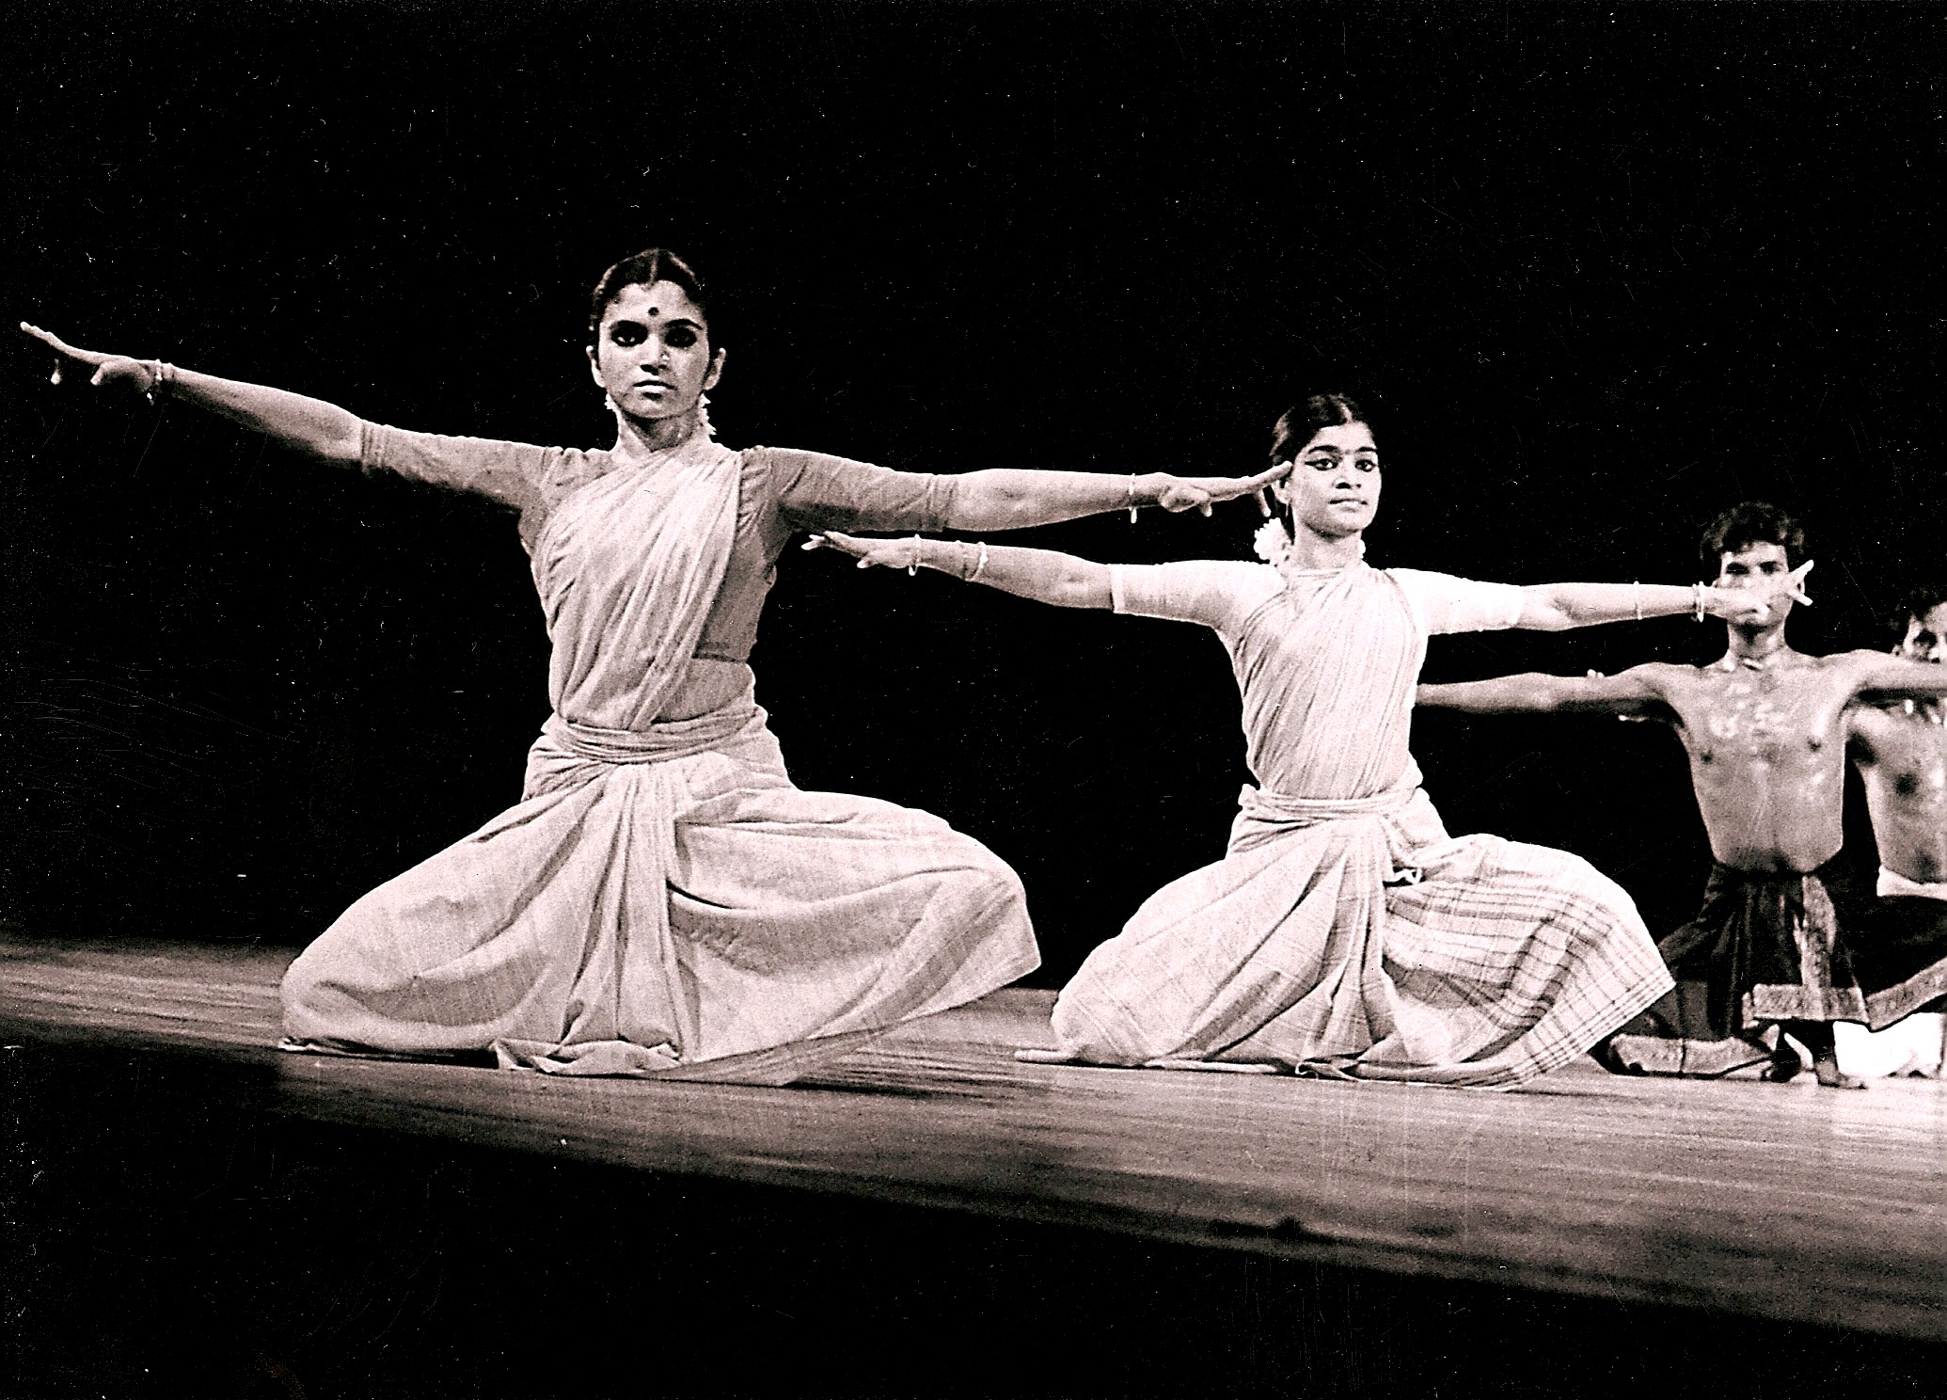

1. (from left to right) Sumitra Gautam, Sujatha Ramalingam, Raghunath Manet, and Sridhar Shanmugam in Chandralekha's *Angika*, performed by the Cultural Center of Madras at the Nritya Natika Festival, New Delhi, November 1995. Photo courtesy of Sangeet Natak Akademi, New Delhi.

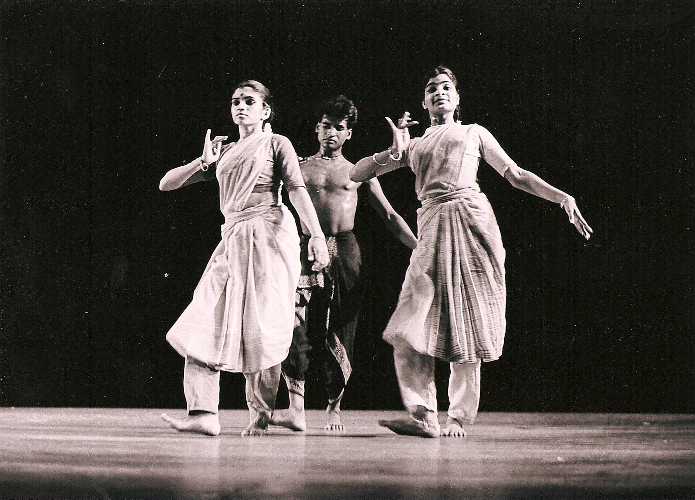

2. (front, left to right) Sumitra Gautam and Sujatha Ramalingam, with Raghunath Manet (back), in Chandralekha's *Angika*, performed by the Cultural Center of Madras at the Nritya Natika Festival, New Delhi, November 1995. Photo courtesy of Sangeet Natak Akademi, New Delhi.

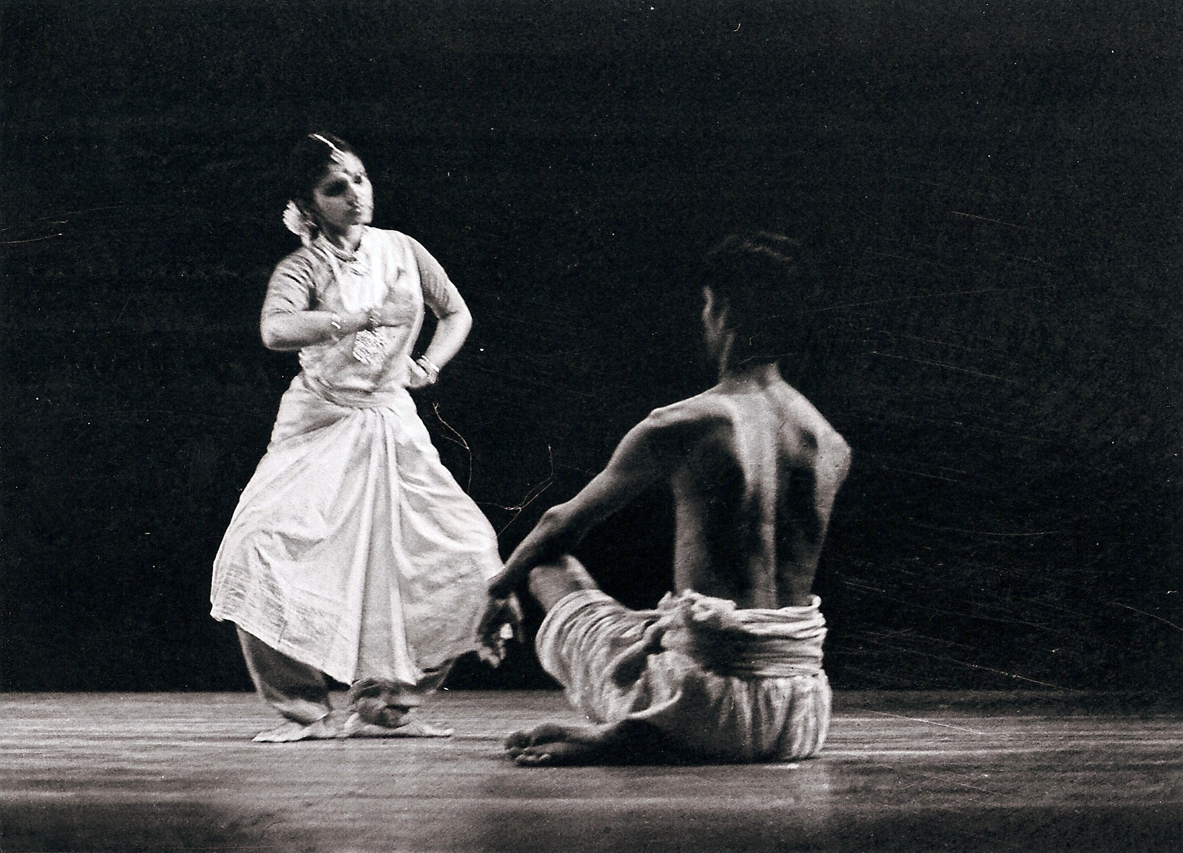

3. Sumitra Gautam (standing) facing another performer from the Cultural Center of Madras in Chandralekha's *Angika*, at the Nritya Natika Festival, New Delhi, November 1995. Photo courtesy of Sangeet Natak Akademi, New Delhi.

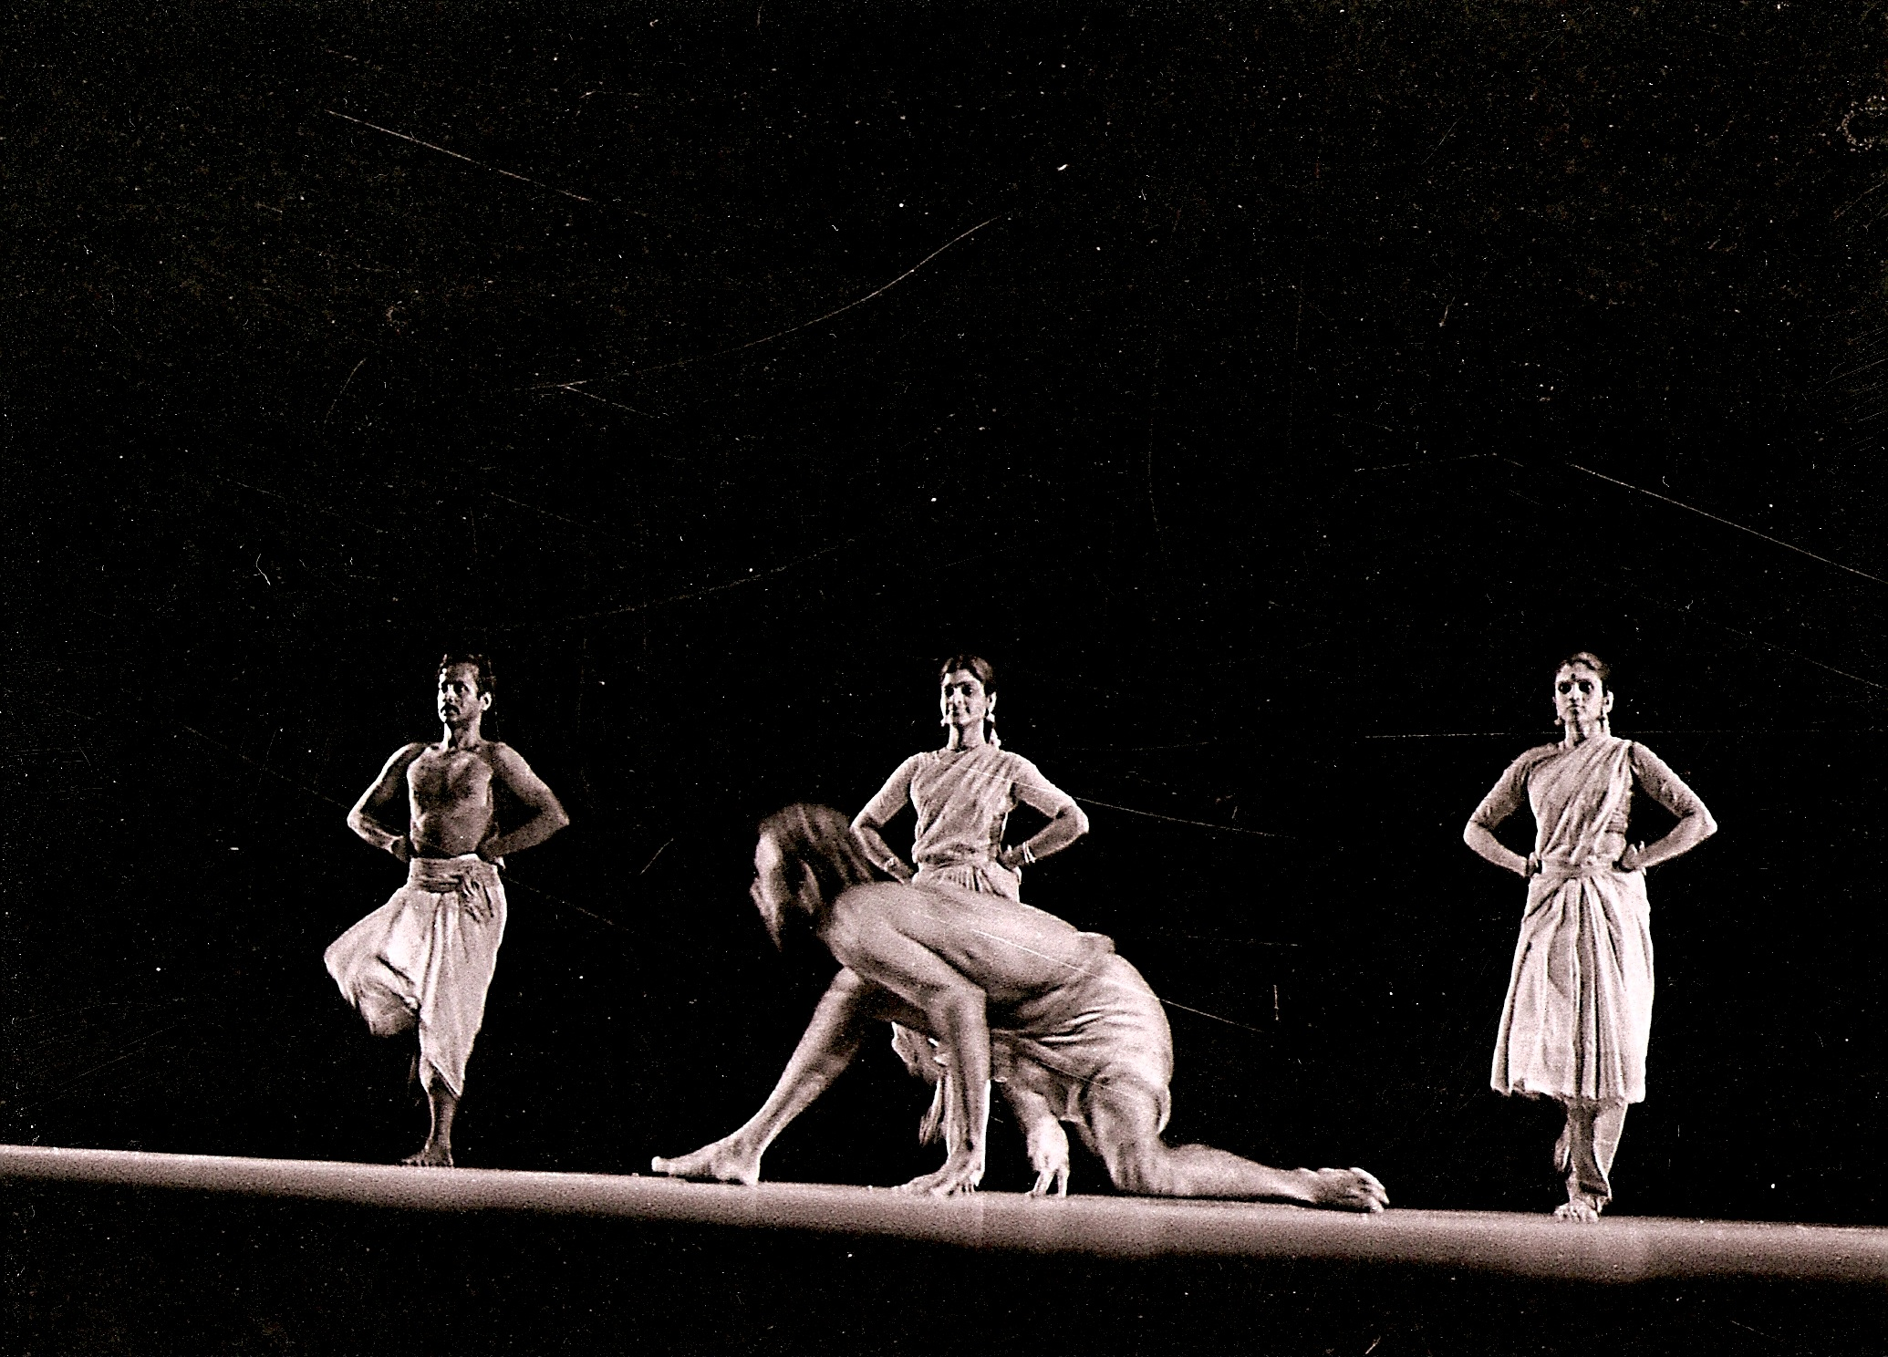

4. (left to right, standing) Sridhar Shanmugam, Sujatha Ramalingam, and Sumitra Gautam stand in stillness as another performer moves across the space in the foreground. Chandralekha's *Angika*, performed by the Cultural Center of Madras, at the Nritya Natika Festival, New Delhi, November 1995. Photo courtesy of Sangeet Natak Akademi, New Delhi.

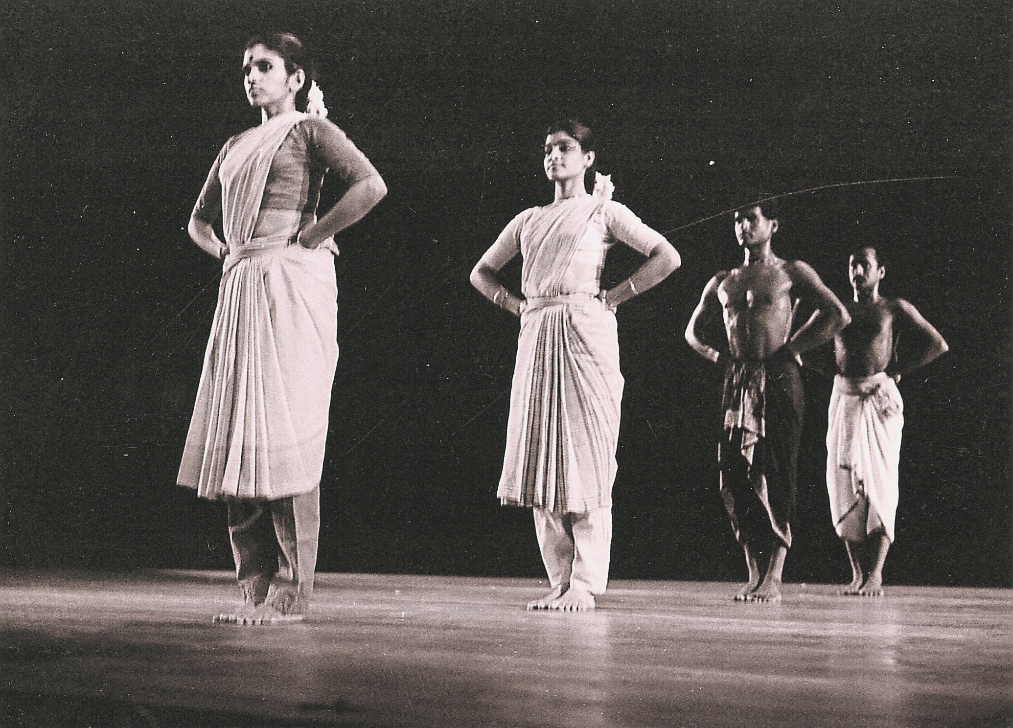

5. (from left to right) Sumitra Gautam, Sujatha Ramalingam, Raghunath Manet, and Sridhar Shanmugam in the Cultural Center of Madras’s performance of Chandralekha's *Angika*, at the Nritya Natika Festival, New Delhi, November 1995. Photo courtesy of Sangeet Natak Akademi, New Delhi.

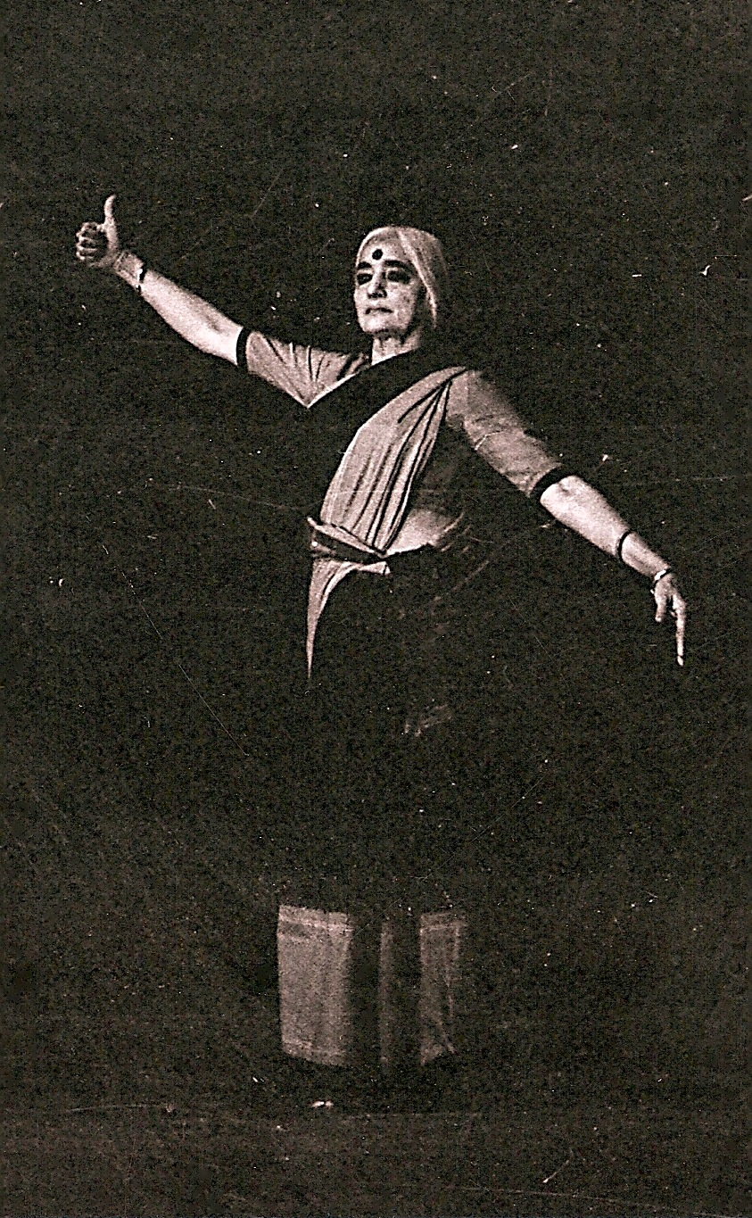

6. Chandralekha at the Nritya Natika Festival, New Delhi, in her choreographic work, *Angika*, performed by the Cultural Center of Madras, November 1995. Photo courtesy of Sangeet Natak Akademi, New Delhi.

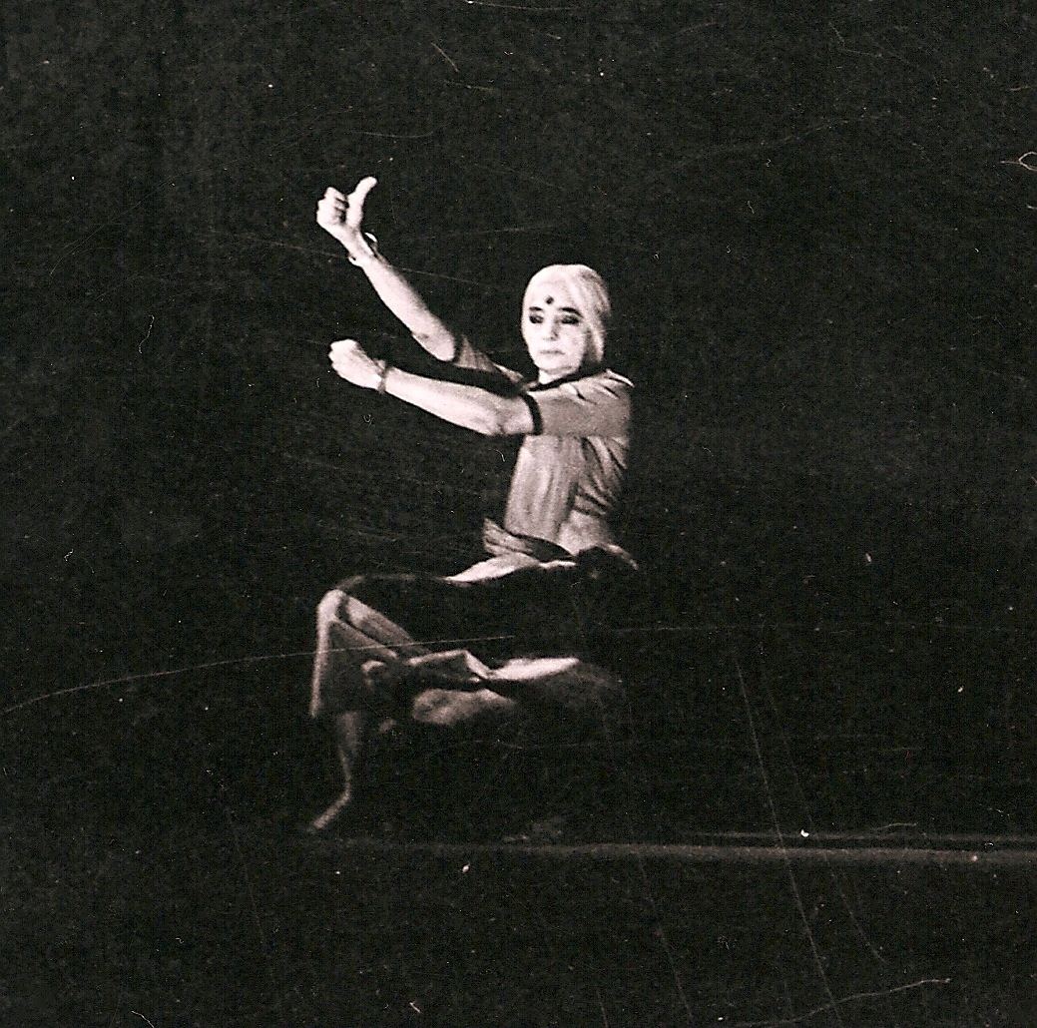

7. Chandralekha at the Nritya Natika Festival, New Delhi, in an arresting image from her choreographic work, *Angika*. Performed by the Cultural Center of Madras, November 1995. Photo courtesy of Sangeet Natak Akademi, New Delhi.

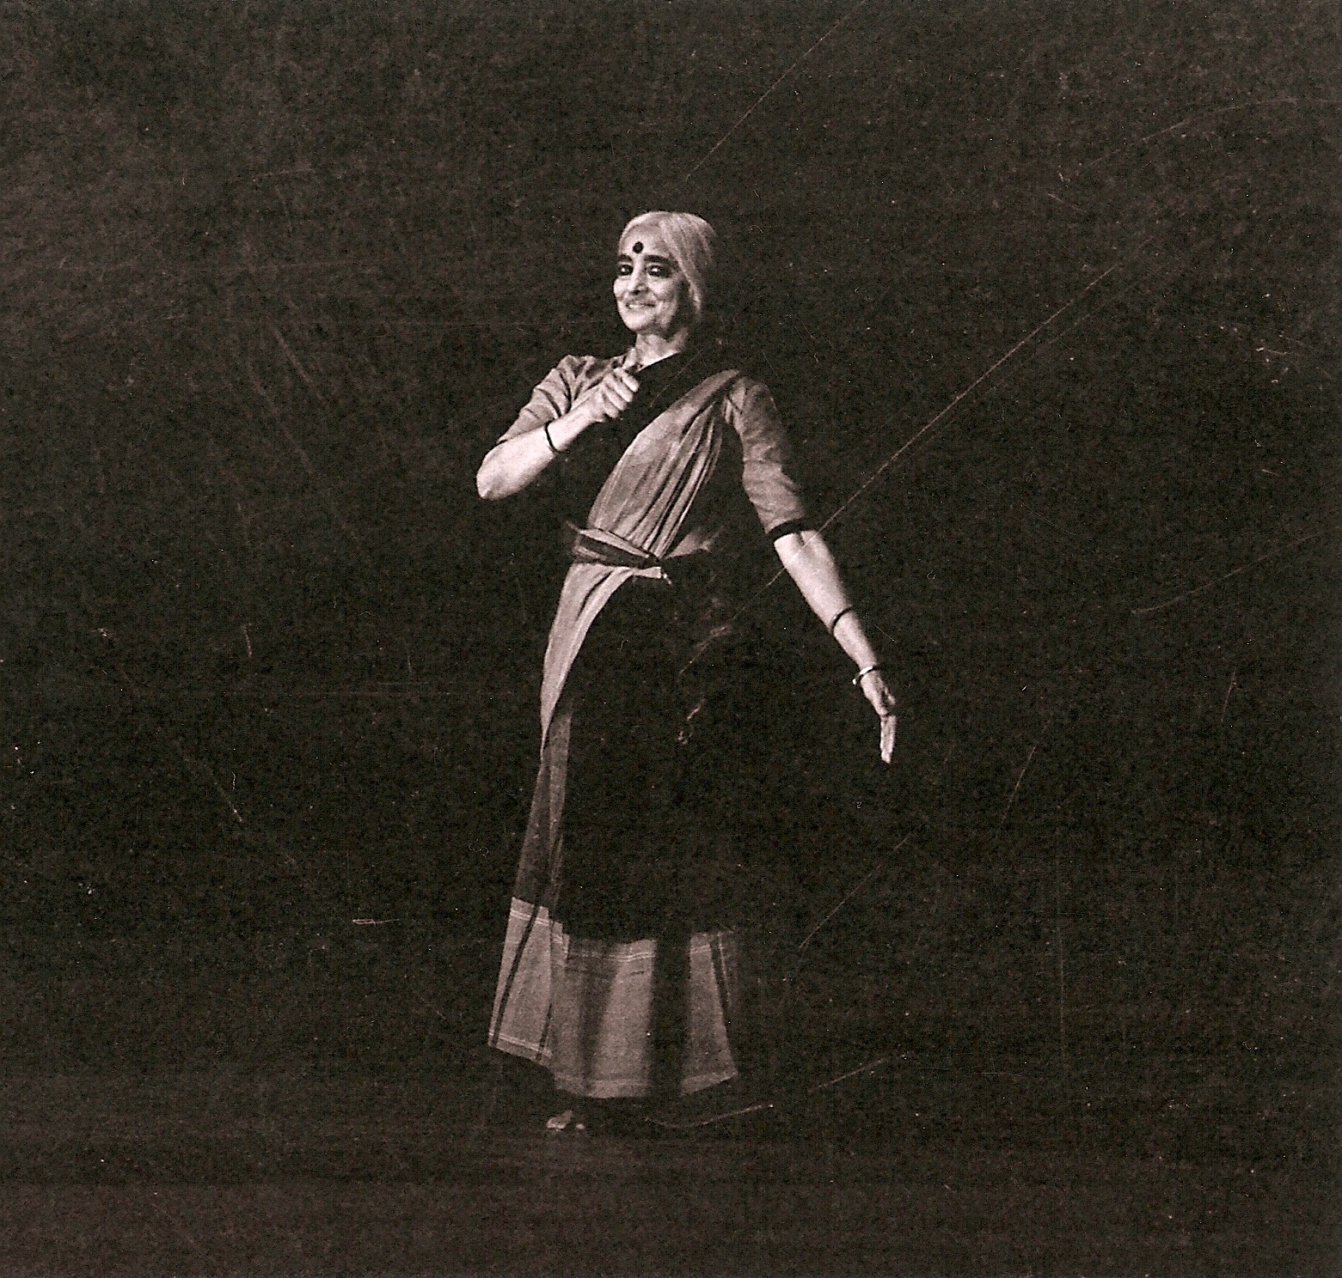

8. Chandralekha at the Nritya Natika Festival, New Delhi, in *Angika*, performed by the Cultural Center of Madras, November 1995. Photo courtesy of Sangeet Natak Akademi, New Delhi.

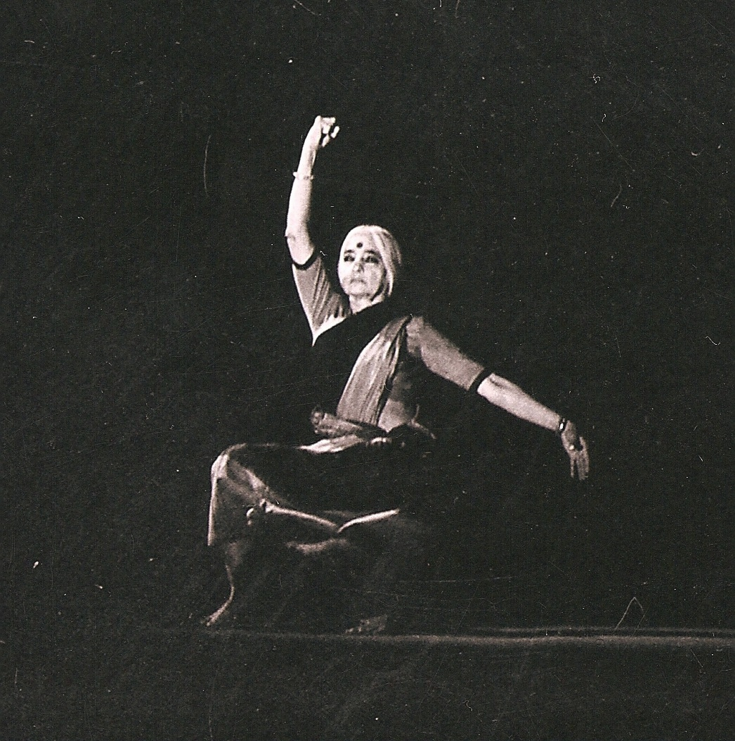

9. Chandralekha at the Nritya Natika Festival, New Delhi, dancing a sequence from *Angika*, performed by the Cultural Center of Madras, November 1995. Photo courtesy of Sangeet Natak Akademi, New Delhi.

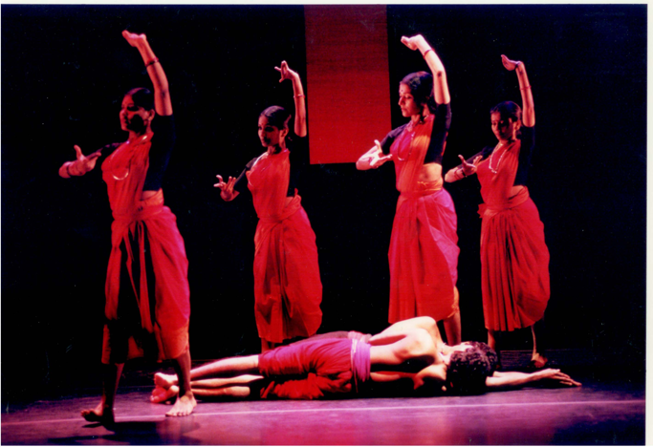

10.

A scene from *Raga: In Search of Femininity*, choreographed by Chandralekha. Performed by the Chandralekha Group at Brooklyn Academy of Music (BAM), Brooklyn, New York, November 18-22, 1998. Stage design by Dashrath Patel; lighting design by Anish Kapoor and Sadanand Menon. Photo by Stephanie Berger; courtesy of BAM Archives.

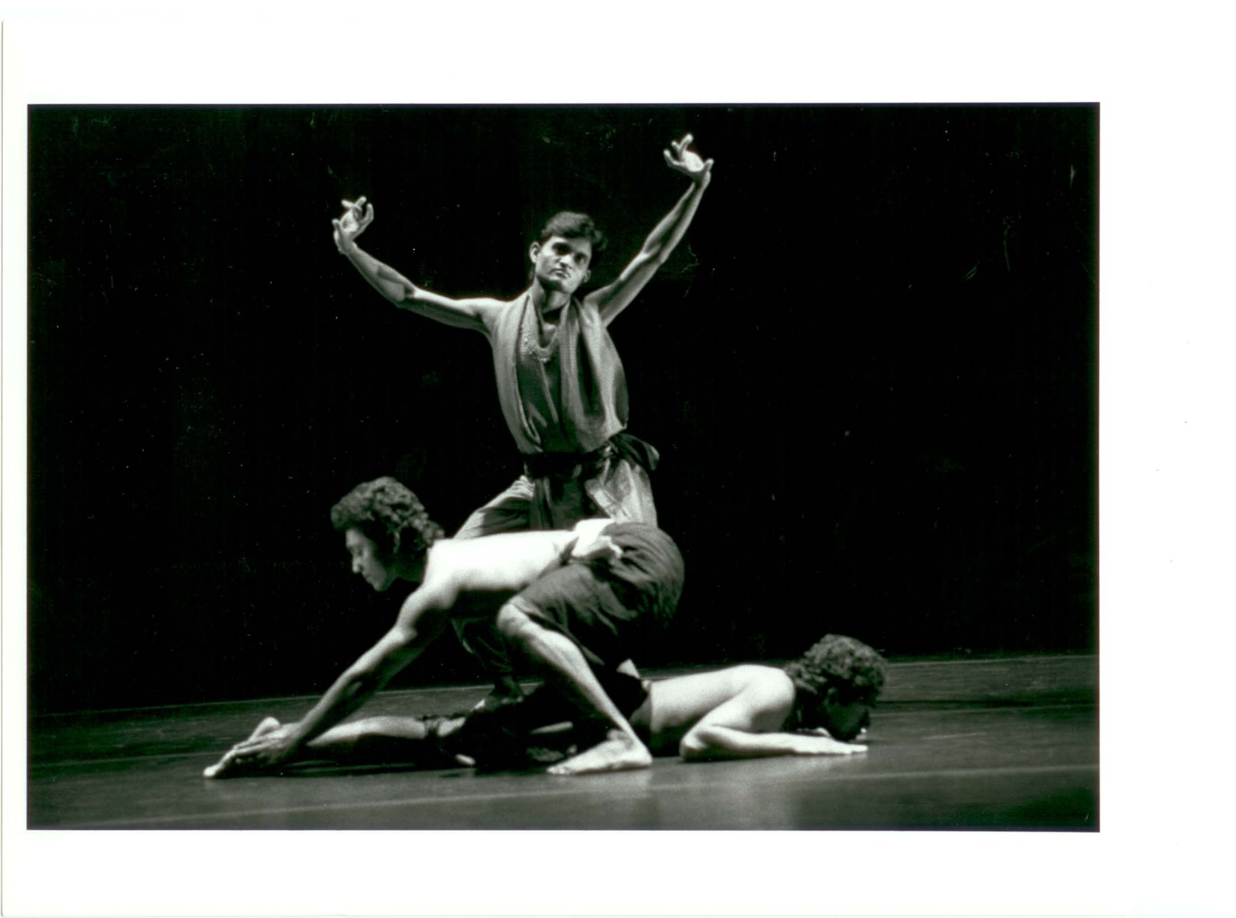11.

V.A. Sunny, Ramachandra Das, and Shaji John in a scene from *Raga: In Search of Femininity*, choreographed by Chandralekha. Performed by the Chandralekha Group at Brooklyn Academy of Music (BAM), Brooklyn, New York, November 18-22, 1998. Stage design by Dashrath Patel; lighting design by Anish Kapoor and Sadanand Menon. Photo by Stephanie Berger; courtesy of BAM Archives.